Institute of Public Care Learning Event of 2017

“Making it Count” – Performance Management to Deliver Outcomes and Manage Demand

4 & 5 October 2017

Jurys Inn London Watford, Clarendon Road, Watford, WD17 1JA
In keeping with our recent successful Partnership events, the event will be highly participative and provide opportunity for colleagues from a diverse range of organisations and roles to share their own experiences and work through some of the demand management issues they are facing and in particular, to discuss what do we need to monitor and understand to assess the impact of the services and resources we employ.

The focus for the event builds on the work of IPC and the papers published by our Knowledge Transfer Fellow Professor John Bolton which have considered how organisations can both deliver outcomes for their local communities and manage demand for social care services. Professor Bolton’s earlier research argued that Councils ought to be able to systematically measure and monitor activities so that they understand whether they are delivering individual and service outcomes required to meet their strategic management objectives.

At the event we will suggest that improving the performance management of key local objectives (mainly for older people services) may assist in delivering the changes required – we have called this approach the “Six Steps”.

We have prepared a mix of IPC presentations and opportunities for shared learning and discussions around the following themes:

- What does a demand management focused organisation look like?
- What should we be counting, and why?
- The art and discipline of performance management
- Developing and supporting an effective performance management culture

A programme for the event is shown below:
Event Programme

Day 1:

09.30 | Registration and refreshments
10.00 | Welcome & Introduction
10.15 | Plenary 1: “Making it Count” Philip Provenzano,  Assistant Director, IPC
11.00 | Tea and Coffee
11.15 | Plenary 2: “What should we be measuring and why?”  Jackie Daru – IPC Senior Consultant
12.00 | Delegate Activity 1 – “Show and Tell Café”  Delegates will be asked to share in small groups one area of work in their organisation that is contributing to effectively managing demand.
12.45 | Lunch
13.30 | Feedback from “Show and Tell Café”
14.00 | Plenary 3 – “Commissioning for an Ordinary Life” – Why do we need to think differently about learning disabilities?  Sarah Broadhurst – IPC Principal Consultant
15.15 | Break
15.30 | Delegate Activity 2  Action learning conversations – (see notes below on suggested preparation for this activity)
16.30 | Reflection and close of Day 1
19.00 | Pre-dinner Session: “How do we measure cost?”  Tony Sanders – CEO, Milestone Group PLC
20.00 | Dinner

Pre-dinner Guest Speaker
Tony Sanders, CEO, Milestone Group PLC

Tony is a business technologist who has built a reputation through his career for using technology to resolve business issues.

With a number of successful businesses to his name, he has more recently turned his attention to the charitable sector where he is using his experience to help identify success and measure outcomes in this highly competitive funding environment.
Day 2:

09.00 | Introduction to Day 2
09.15 | Plenary 4 – Managing demand and the need to change behaviour  Mick Mellors – IPC Associate  Nic Rattle – IPC Principal Consultant
10.30 | Break
10.45 | Plenary 5 - Developing a performance management culture – the role of “leaders”  Philip Provenzano/Juliet Bligh – IPC Principal Consultant
11.45 | Break
12.00 | Delegate Activity 3 – “Ideas Café”  Following the completion of a brief self-assessment, delegate will be asked to share in small group that they would like to “stop, start and keep doing” in their organisations to deliver effective outcomes and manage demand.
12.45 | Summing up session
13.15 | Close and lunch

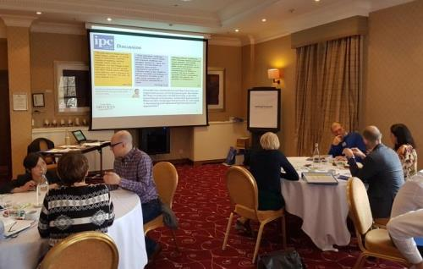

Some preparation please …
Action Learning
As always, we want to make sure you have plenty of opportunity to share and discuss your organisation’s plans, innovations or challenges in relation to the main conference theme with other partners.

With this in mind, we have included an action learning session on the afternoon of Day 1 with an opportunity to describe to a small group of delegates a current demand management issue that you are dealing with your organisation. Using an action learning approach, IPC will facilitate the group to offer you advice and suggestions to resolve the challenges for you to consider.

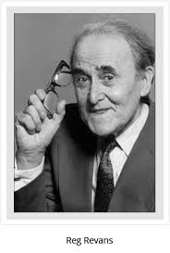
Pioneered by Professor Reg Revans and developed worldwide, action learning provides a well-tested method of accelerating management and organisational learning which enables people to receive practical advice from fellow participants and handle difficult issues in the workplace more effectively.

An Action Learning Set is a small group (usually six to eight people), who meet with a facilitator to work on real problems, focus on learning and actually implement solutions.

It is a form of learning by doing. Participants learn from their attempts to change things – whether or not they were successful. In an action learning set participants can explore issues they want help with and, hopefully, resolve specific problems facing local areas.

Learning sets have proved to be highly effective for introducing new ways of working and supporting change in and across organisations.

It is based on some key ideas:
- The person with the problem is the real expert.
- People learn best when working on real problems.
- People learn best when they share experience and knowledge.
- Having different perspectives on real-work problems and dilemmas enables clearer and more creative thinking.
- Learning by doing – the approach involves focusing on the learning from those problems and on implementing practical solutions.
- There is no real meaningful learning until action is taken and reflected on.
- We learn most when self-motivated to take action.

Please complete the template below and return it to us by Thursday 28th September so that we can organise and facilitate the session effectively.

Action Learning Set Template

Name……………………………………………………………………………

Organisation…………………………………………………………………..

Brief summary of the context for demand management challenge in your organisation

What would you like colleagues to help you with? What is the question you would like to have discussed?

Please return to Emma Beal at ipcevents@brookes.ac.uk by Thursday 28th September.

Thank You

